Week Ending: |  |  | DAY: |  |  |  |  | Subject: OWOP
Duration: 60mins per lesson |  |  |  |  |  |  |  | Strand: My Global Community
Class: B1 |  |  | Class Size: |  |  |  |  | Sub Strand: Technology In Communication
Content Standard:  B1.5.4.1. Recognize technology tools in communication |  |  |  |  |  | Indicator:  B1.5.4.1.1 Identify technology tools in communication |  |  |  | Lesson:  1 OF 1
Performance Indicator:  - Learners can describe the conditions of the weather |  |  |  |  |  |  | Core Competencies:  Communication and Collaboration Critical Thinking and Problem
Teaching/ Learning Resources |  |  |  | Pictures, Charts, Video Clips
New words |  | Technology, communication, Gong-gong drums, bells, mobile van, community information centre
References: OWOP Curriculum Pg. 17
DAYS | PHASE 1: STARTER |  |  |  | PHASE 2: MAIN |  |  |  | PHASE 3: REFLECTION
 | We talk to people through many ways. The objects or things that help us to talk to people who are far from us are called communication tools. Communication tool is a device used to send and receive information. Do you know of any device that you can use to talk to Mum or Dad when you are in school? |  |  |  | Ask learners to talk about the things needed to facilitate technology tools in communication. The learners should present their findings to the class.  Through brainstorming ask learners to talk about different communication tools and how they work.  Examples of communication tools are the gong-gong, dondo, drums, bells, mobile vans, and community information centres.  Let learners in groups talk about technology tools used for communication e.g. gong-gong, drums, bells, mobile vans and community information centers. |  |  |  | Homework 3 Color the bell below.  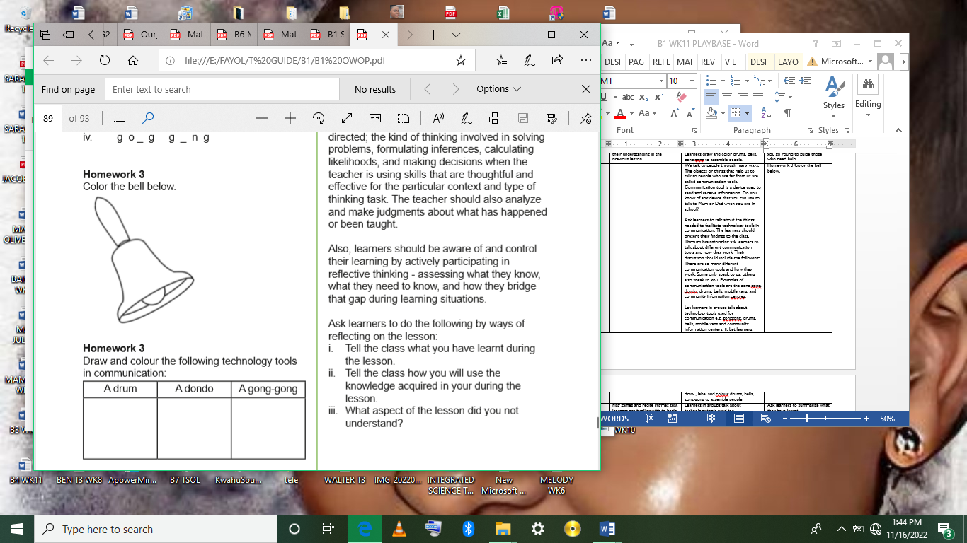  Homework 3 Draw and colour the following technology tools in communication:  A druem A dondo A gong-gong  0020
 | Play games and recite rhymes that learners are familiar with to begin the lesson.  Ask learners questions to review their understanding in the previous lesson. |  |  |  | Learners in groups talk about technology tools used for communication e.g. mobile vans, and community information centers.  Learners draw and color mobile vans, and community information centers to assemble people. |  |  |  | Ask learners to summarize what they have learnt.  Let learners say 5 words they remember from the lesson.
 | Play games and recite rhymes that learners are familiar with to begin the lesson.  Ask learners questions to review their understanding in the previous lesson. |  |  |  | Learners in groups talk about technology tools used for communication e.g. mobile vans, and community information centers.  Learners draw and color mobile vans, and community information centers to assemble people. |  |  |  | Ask learners questions to review their understanding of the lessson.  Give learners task to do whiles you go round to guide those who need help.

